

**YEAR: 9**

**2020**

**SUBJECT: Science**

**TEST: Ecosystems**

**TIME: 40 minutes**

**QUESTIONS: 10 Multiple Choice (10 marks)**

**1 Short Answer (25 marks)**

**1 Extended Answer (10 marks)**

**TOTAL MARKS: marks**

**DO NOT WRITE ON OR MARK THIS PAPER**

**SECTION ONE—MULTIPLE CHOICE** (6 marks)

This section has **10** questions. Answer **all** questions on the separate Multiple-choice Answer Sheet provided. Choose the **best answer.**

_______________________________________________________________________________________

1. In any ecosystem, bacteria and fungi are
2. herbivores
3. secondary consumers
4. decomposers
5. producers
6. The energy from sunlight is converted into chemical energy
7. in nuclei
8. in photosynthesis
9. in respiration
10. using the oxygen from carbon dioxide
11. 3. Producers are vital in ecosystems because:

1. they can make the food materials they need

b) animals can consume them

1. they can use sunlight to use up carbon dioxide
2. they are the only organisms that can make food materials
3. 4. The chemical reactions of photosynthesis involve:
4. oxygen and water combining to form sugar and carbon dioxide
5. carbon dioxide and water combining to form sugar and oxygen
6. oxygen and carbon dioxide combining to form sugar and water
7. carbon dioxide and sugar combining to form oxygen and water
8. 5. A community consists of:
9. the organisms in an ecosystem and their physical surroundings
10. the habitat and environment of all the different populations in an ecosystem
11. all the organisms in an ecosystem
12. the habitat and abiotic factors in an environment

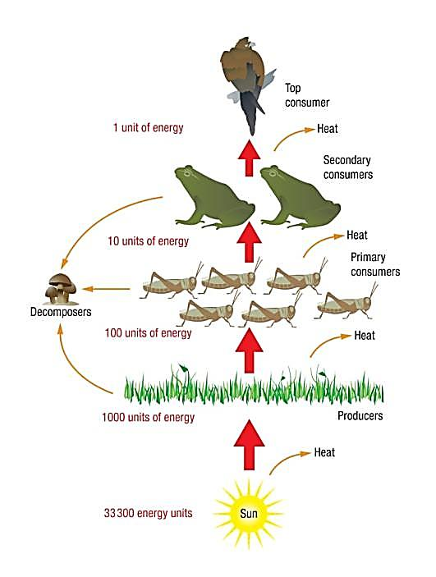**Refer to the diagram below to answer questions 6, 7 and 8**

1. There are more organisms at the bottom of the food pyramid because

a) top consumers eat more than secondary consumers

b) primary consumers reproduce more quickly than secondary consumers

c) the amount of energy available to support organisms further up the pyramid decreases

d) secondary consumers eat more than primary consumers

1. A possible food chain from the pyramid would be:
2. grasshopper → eagle → frog → fungus
3. Sun’s energy → grass → grasshopper → eagle
4. Sun’s energy → grass → fungus → grasshopper
5. grass → grasshopper → frog → eagle
6. Which of the following statements is **incorrect**?

a) Nutrients and energy are recycled.

b) All of the organisms respire

c) There are several possible food chains in this food web

d) The source of energy in this system is the Sun

1. 9. The following table compares the physical factors in a rain forest with a beach sand dune environment.

|  |  |  |
| --- | --- | --- |
| **Physical factor** | **Rain forest** | **Beach sand dunes** |
| 1. Soil movement | 1. Soil fairly stable – plants do not become buried | 1. Soil moves around rapidly burying plants |
| 1. Salt content | 1. Low salt content in soil | 1. High salt content soil |
| 1. Soil water | 1. Lots of moisture | 1. Very little moisture |
| 1. Soil fertility | 1. Moderate to low in nutrients | 1. Low in nutrients |
| 1. Wind | 1. Wind speed low | 1. Strong winds |

1. Identify which the type of plant would grow **best** in a beach environment.
2. A fern that requires a lot of moisture and that dries out easily in the wind
3. A plant with very fast-growing underground stems that can tolerate drying out and being buried
4. A fast-growing tree that requires moderate soil moisture, can tolerate salt but that does not survive being battered by wind-blown particles
5. A climbing vine that grows in the shade and needs very high humidity in the air

10 Two species of water animal were placed in a tank and the numbers of each were recorded over   
 two weeks. The population sizes are shown in the graph below.

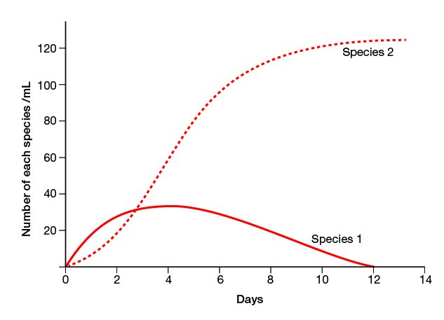

1. Propose which of the following seems a reasonable deduction.
2. Species 1 ate Species 2.
3. Species 2 ate Species 1.
4. Both species 1 and 2 were eaten by a predator.
5. Species 1 and 2 were in competition.

**END OF MULTIPLE CHOICE SECTION**



**SEMESTER ONE 2020**

**Ecosystems Test:**

**Marking Key**

**NAME:**

**FORM:** **DATE:**

Multiple Choice Short Answer Extended Answer Total

**/45**

**/8**

**27/**

**/10**

**SECTION ONE:** Multiple choice answers

Cross (X) through the correct answer.

|  |  |  |  |  |
| --- | --- | --- | --- | --- |
| **1** | a | b | xxxx | d |
| **2** | a | xxxx | c | d |
| **3** | a | b | c | xxxx |
| **4** | a | xxxxx | c | d |
| **5** | xxxxx | b | c | d |
| **6** | a | b | xxxx | d |
| **7** | a | b | c | xxxx |
| **8** | xxxx | b | c | d |
| **9** | a | xxxx | c | d |
| **10** | a | b | c | xxxx |

**SECTION TWO: Short Answer (27 marks)**

Answer the questions in the spaces provided.

_______________________________________________________________________________________

1. Read the following scenario and answer the following questions. Think about other conditions, not just the ones mentioned.

Desmond the dolphin inhabits the ocean ecosystem in the cool waters surrounding Point Peron. Desmond is a bottlenose dolphin and he actively seeks out his diet of fish, such as catfish and squid.

1. In the table below, list some of the biotic and abiotic factors that can affect Desmond’s marine ecosystem

**(6 marks)**

|  |  |
| --- | --- |
| Abiotic | Biotic |
| 1.  current | 1. food like fish/squid/catfish |
| 1. temperature | 2. Sharks |
| 1. sand/rock /sunlight etc | 3. Humans |

1. State and describe the relationship between Desmond the dolphin and a tape worm and the outcome for each. **(5 marks)**

___parasitism (1)

Involves 2 species (1) symbiotic (1)

Desmond is harmed (1) tapeworm benefits. (1)

Desmond also survives on crustaceans. Desmond has a strong tail that allows him to swim away from his predators such as sharks and killer whales.

The seafloor of Point Peron is covered with sea grass that the catfish eat. The sea grass is able to grow because of the large amount of sunlight reaching the sea floor. Bacteria and other microorganisms also thrive in this ecosystem.

1. Using all the information given and some of your own knowledge about the ocean ecosystem, construct a labelled food web with at least two (2) producers, three (3) first-order consumers, Desmond the dolphin, and a top consumer. **(7 marks)**

This will depend on what the students choose. Deduct 2 marks if there are no arrows, just lines.

Deduct 1 mark if the arrows are going the wrong way.

1. Include and label the source of energy for this ecosystem **(1 mark)**

Sun

1. Matter and energy both flow through a food web. **Compare and contrast** the flow of energy and matter in a food web. You can use the food web you constructed as a reference. **(4 marks)**

Energy flows in one direction (1)

Matter and nutrients is recycled (1)

The amount of energy in a food web decreases (1)

The amount of matter stays the same. (1)

* Energy flows in one direction
* Matter and nutrients flows in a circle (cyclical, is recycled)
* The amount of energy decreases through the chain

1. Whales and sea birds both feed on krill. Name and describe this kind of relationship. **(2 marks)**

Competition (1)

The two species are fighting for the same resource (1)

1. **(2 marks**)

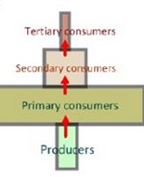

The diagram above is an unusual food pyramid because it shows a pyramid of numbers, not biomass. Suggest the name of an organism that could fit into each level.

Producer ____

Primary consumer

Secondary consumer

Tertiary consumer

eg tree /caterpillar/bird/cat cabbage/snail/bird/hawk **½ mark each.**

**SECTION THREE: Extended Answer**

**(8 marks)**

**Name and describe** four major ways in which ecosystems are damaged by humans.

Any 4 eg habitat destruction through clearing, altering waterways, air pollution, water pollution, climate change, reducing biodiversity. Need to explain what it does to the ecosystem.